

School of Computer Science, UPES, Dehradun.

A

Lab 2

On Software Engineering

B.TECH. - V Semester

**Submitted to:**

Dr. Hitesh Kumar Sharma

**Submitted by:**

Name: Ishika Mehrotra

Batch: Devops B1

Sap Id: 500124411

Roll No.: R2142230281

**Lab Exercise 2- Working with Git Reset**

1. **Set Up the Repository**

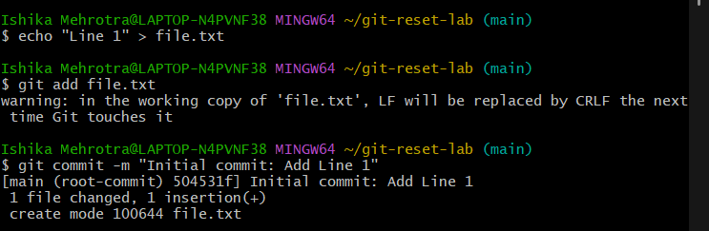

1. **Add a second change:**

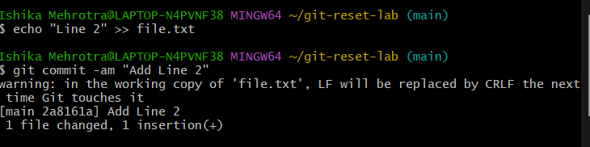

1. **Add a third change:**

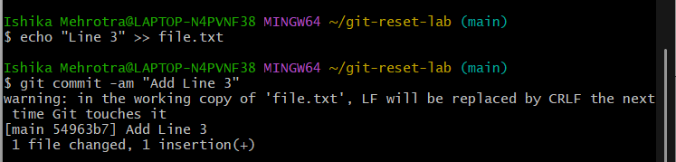

1. **Check the commit history:**

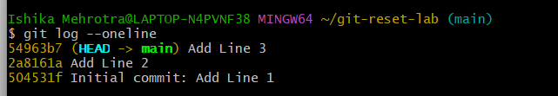

**2. Use git reset –soft**

1. **Reset to the second commit:**



1. **Check the commit history:**

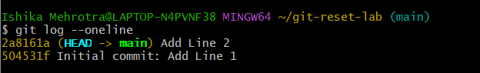

1. **Verify the staged changes:**

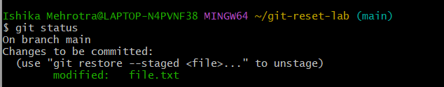

1. **Use git reset –mixed:**

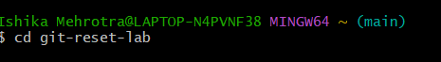

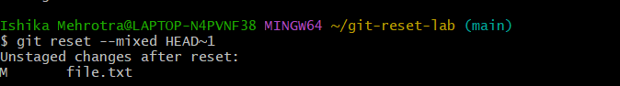

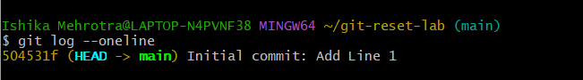

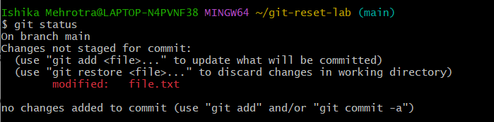

1. **Use git reset –hard**

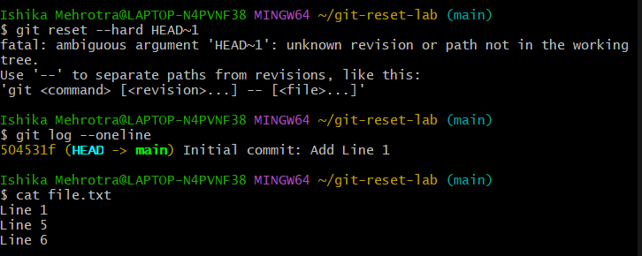

**5. Use git reset with a Commit Hash**

